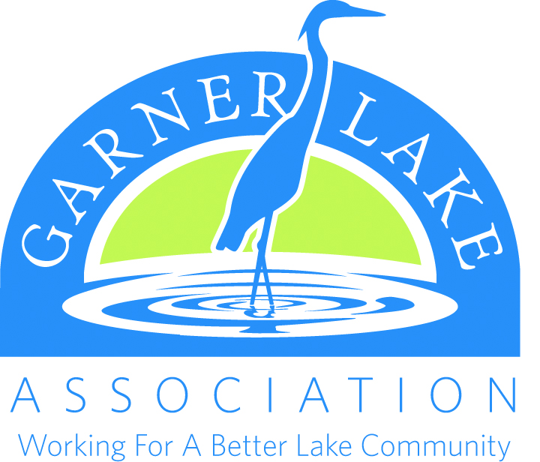
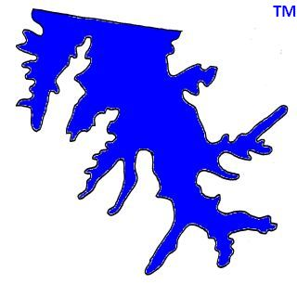

Dear Garner Lake Area Resident: February, 2020

This letter is to invite you to join, or renew your current membership in the GLA for 2020. The Garner Lake Association is governed by a volunteer board, elected by the membership. We have maintained current dues levels for many years now. Your GLA membership dues (only $20 per year) support many projects. All are designed to directly benefit all Garner Lake residents by enhancing:

• Property Values • Boating • Fishing Sailing • Swimming • Water Quality

The lake is our mutual 240-acre backyard. Ours are friendly, unique neighborhoods and your support will help keep it that way.

During 2019, GLA volunteers:

- Paid to add more grass carp for weed control. The carp have been a success!
- Sprayed to remove honeysuckle and trees from the dam as required by the state dam inspectors.
- Repaired holes in the dam as required by the state dam inspectors.
- Cleaned trash off the dam and around the lake regularly.
- Cleaned leaves and debris from the weir (overflow) regularly to maintain proper drainage.
- Sent informational email notifications to more than 350 residents on our list.
- Maintain well, pump and pump enclosure.
- Pay for yearly well inspection.
- Paid over $4500 to run the pump for many days to maintain level during a dry period.
- Maintain insurance for dam and lake.
- Maintain contact with the City of Lakeland regarding lake pollution and erosion.
- Maintain informational website www.garnerlake.com .
- Own Garner Lake Management, LLC which owns and manages Garner Lake.
- Co-ordinated with Garner Lake Fireworks for the annual 4th of July event.

ALL dues collected by Garner Lake Association & ALL fees collected by Garner Lake Management, LLC go to benefit the lake and protect our property values.

Both Garner Lake Association & Garner Lake Management, LLC are non-profit entities.

Please renew your membership in GLA as we move forward into 2020.

You must be a member of GLA to have any say in the management of the lake.

Visit our website www.garnerlake.com .

Thank you!

The Garner Lake Association Board
Dave Brown, President

(Over)

