
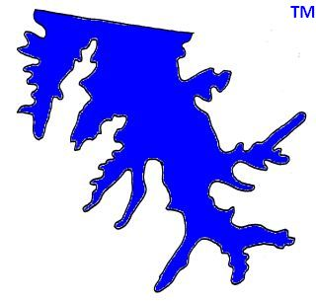

2020 GLA MEMBERSHIP FORM

NAME _______________________________________________________

ADDRESS _______________________________________________________

_________I am a resident of Lakeland Estates, East Shores, Long Landing, The Pointe, The Preserve or Windward
Slopes.

_________I do not live in a Garner Lake subdivision.

E-MAIL_________________________ ____________________________________________________

Phone_______________________________________________________________________________

*All information above is STRICTLY for GLA use only and will not be given, sold or otherwise shared. *

Annual dues $ 25.00

The pump fund can always use donations. Pump Fund contribution $___________

We incurred significant legal expenses for lake purchase. Legal Fund contribution $___________

Total Enclosed $_____________
Please make checks payable to: GLA
Send to:
Treasurer,
Garner Lake Association
9687 White Spruce Cove
Lakeland, TN 38002

ALL CONTRIBUTIONS TO GARNER LAKE ASSOCIATION DIRECTLY BENEFIT YOUR LAKE AND NEIGHBORHOOD.
We are GLA, a voluntary organization of Garner Lake area residents that provides many and various services to its members as well as all lake area residents who reside in subdivisions bordering Garner Lake. GLA’s goal is to maximize the quality of life and property values of Garner Lake area residents.
(Note that Garner Lake Management, LLC is a separate entity with separate fees.)

